From: http://davidstockmanscontracorner.com/why-the-chart-monkeys-are-about-to-meet-their-maker/

Why The Chart Monkeys Are About To Meet Their Maker
By David Stockman. Posted On Tuesday, October 23rd, 2018
The chart monkeys were sweating bullets today because the casino's safety blanket is in danger of falling off the ledge. We are talking about the 200 DMA of the S&P 500, which sits at 2768 and has been the site of hand-to-hand combat among the robo machines for nearly two weeks now.
But this morning the index sliced through its guide rails, plunging to a low of 2690 (3% below the 200 DMA). As the trading day progressed, the machines and cheerleaders of bubble vision took turns coaxing it back to safety, but it was not to be---with the index closing at 2740.
So unlike the February, April and May swoons earlier this year, which all perfectly bounced off the magic 200 DMA (as shown below), this time was different. Both the carbon and silicon units finally went home worried about what comes next.
Imagine that. Thanks to maniacal bond buying and interest rate pegging by the central banks, people playing what should be the most dangerous game in the financial universe---punting in the equity markets----have not had a thing to worry about for the last nine years. Except to count their winnings.
Indeed, buying what's going up and hitting the bid during minor dips has been the hands down winning strategy ever since the March 2009 bottom. Yet that also tells you all you need to know about why American capitalism is failing so badly.
After all, how could the momo stampedes of the casino's herd of speculators be an efficient allocator of capital?
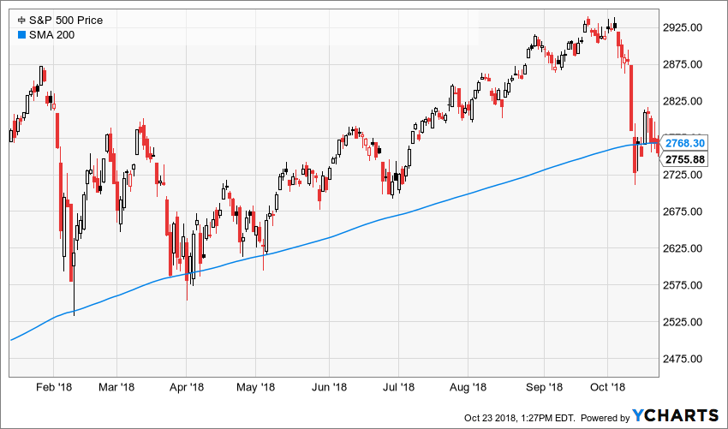
What we are saying, of course, is that Wall Street no longer hosts an honest capital market. Nor is it a place where savers and investors bring their money in search of honestly priced securities issued to fund productive investments in the main street economy.
Instead, it's about as pure a gambling casino as can be confected. For one thing, it has been more than two-and-one-half decades since any net equity at all was raised on Wall Street.
That's right. Yet a capital market which raises no capital, obviously, is hardly that.
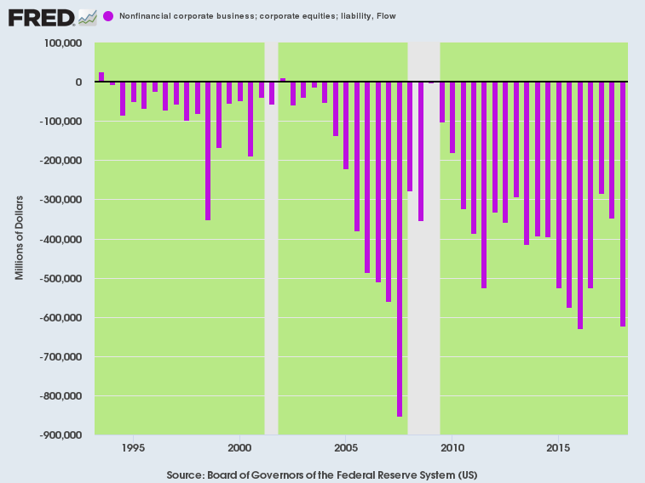
Likewise, the overwhelming share of new debt issuance goes either to refund existing obligations or as distributions via stock buybacks, dividends and cash funded M&A deals to holders of existing equities.
In short, Wall Street has overwhelmingly become a venue for churning, liquidating and inflating existing equity securities in the secondary market; and a place where the tsunami of cheap, below-market debt fostered by the central banks predominantly finances speculative carry trades, not productive assets.
And the proof is in the pudding. Since the turn of the century there has been no increase---as in nichts, nada and nugatory---- in real net business investment.
The chart below is a striking indictment of Bubble Finance because self-evidently you can't grow an economy when its investment rate has been standing still for nearly one-fifth of a century.
Needless to say, the ruling Keynesians on Wall Street and at the Fed never let this chart see the light of day.
They always present gross business investment and its growth rate, pretending that the massive amounts of capital consumed in current production each year don't even exist.
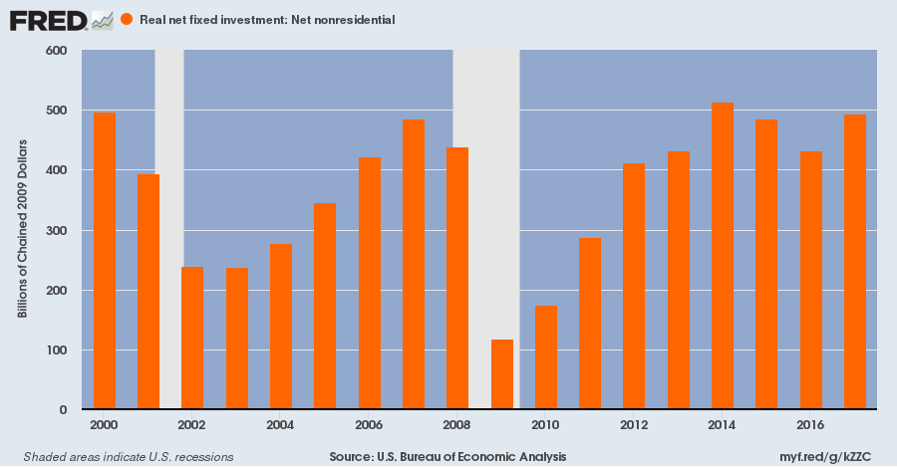
In fact, the main stream narrative is a marvel of obfuscation. Even during the current sell-off owing to the faltering housing and auto sectors, among other gathering economic clouds, the talking heads of bubble vision have been busy hyping the notion that a CapEx boom is coming to the rescue.
But how could they possibly believe it?
During the post-2000 money printing and business debt binge, constant dollar CapEx grew by $555 billion, while real capital consumption rose by $547 billion.
We'd call that close enough to the same thing for government purposes. We'd also say that studied ignorance of this chart is just one more example of how the Wall Street narrative has become completely divorced from main street fundamentals.
Stated differently, the Keynesianized precincts of the casino are in the business of cherry-picking the data to fit the sell-side narrative. Indeed, the true facts of the US economy scream out, "don't buy", even as the Street's crafted narrative suggests "back-up the trucks".
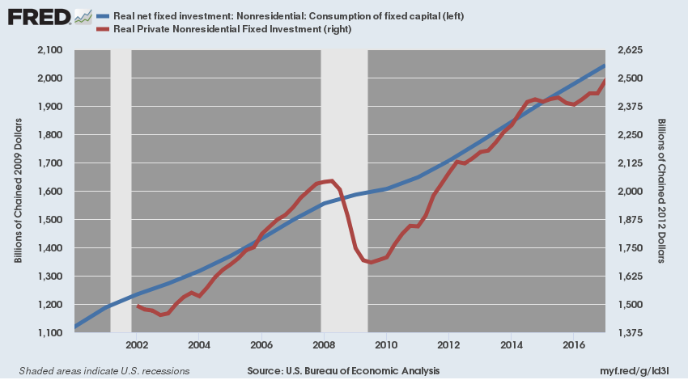
Needless to say, Wall Street's Fake Growth narrative works splendidly---so long as the central banks are pumping liquidity, confidence and price-keeping narratives into the casino. But today's negative pin action---notwithstanding the afternoon rebound off the lows---had the talking heads nervous as wet hens.
That is, the newly intensified drumbeat of Fed-hazing and hand-wringing about whether the FOMC should "pause" in its rate hiking cycle after December tells you all you need to know. The very idea that after dithering for 10-years on the zero bound that the Fed is now moving too fast is not merely preposterous; it's a tell-tale sign that the Cramer Crowd is about ready to loose its nerve and head for the hills.
If there was ever a Fed "behind the curve" it is the one pictured below. The money market rate (red bars) has been deeply below inflation (blue bars) since 2009, and even now is not winning the race with the CPI to reach break-even.
It goes without saying, of course, that negative real money market rates have been the mothers' milk of speculation since time immemorial. So Wall Street's growing objection to the Fed's tightening cycle in the context of the chart below is just one more proof that today's egregious bubbles are being held aloft by the after-burner fumes of a central bank printing binge that is already fading into the rearview mirror.
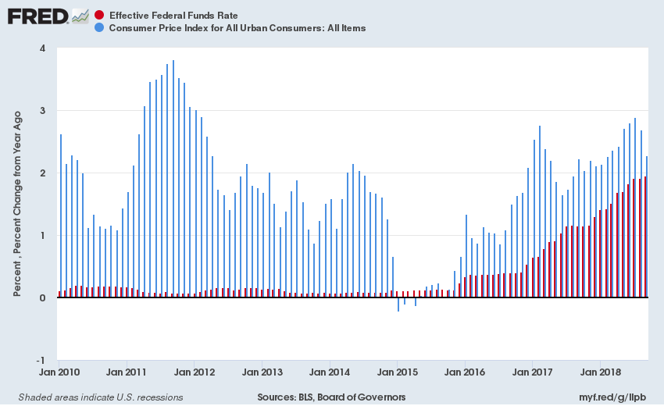
In fact, we are now at full monte QT with the Fed shrinking its balance sheet at a $600 billion annual rate, thereby setting up "the mother of all yield shocks" as the Trumpite/GOP unleashes the greatest late-cycle Fiscal Debauch of all-time.
There is actually no historical parallel to the on-coming crunch. For example, the previous worst late cycle case was 2007. Back then the Federal deficit clocked-in at $160 billion, but the Fed was still expanding its balance sheet and scarfed-up $50 billion of Uncle Sam's emissions.
So on a net basis, the flow of government debt into the Wall Street bond pits from Washington was a mere $110 billion or 0.8% of GDP.
The phrase "you ain't seen nothing yet" comes to mind, however, when you look at the current numbers. To wit, the $1.2 trillion of new Treasury borrowings during the current year plus the Fed's dumpings will total $1.8 trillion or a staggering 8.5% of GDP needing to find a home in the bond pits.
Still, the nervous nellies fluttering around the 200 DMA today are not yet even focussed on that yield jarring reality. They are actually losing their lunch over the comparatively trivial prospect that the Fed may nudge the money market rate back into positive inflation-adjusted territory some time in 2019 for the first time in a decade.
Actually, today's Federal funds rate obsessed talking heads are the equivalent of battle ship admirals.
That is, central bank rate manipulation is yesterday's story. What happened this time around is the giant balance sheet eruption shown below; and what lies ahead is a shrinkage rate per annum that is larger than the Fed's entire $590 billion balance sheet---the accretion of 88 years---as recently as April 2002.
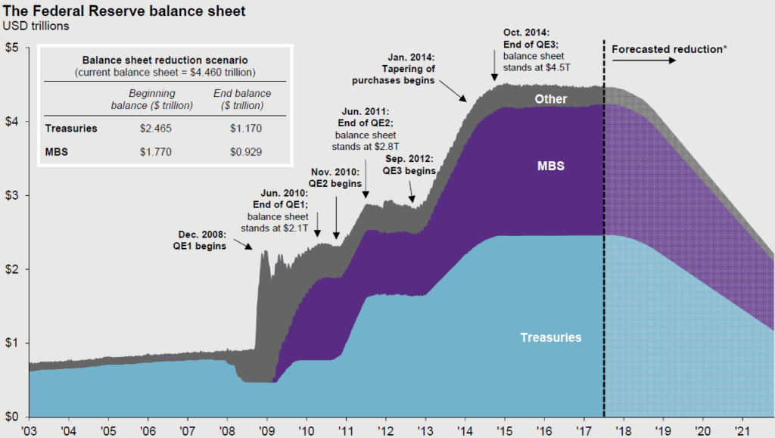
So we are quite confident that the casino is clueless about the real crunch coming down the pike. And we are also quite confident that the chart monkeys will soon loose it if the 200 DMA is not decisively recovered in the next several trading sessions.
Indeed, the fragility of the current market was wonderfully depicted by last night's [Oct 22's] King Report with respect to Monday's desperate attempt to hold the 200-DMA.
The problem for the 200 DMA Rescue Team is that each time over the past few sessions that they push the S&P 500 index above its 200 DMA, real sellers appear. This occurred on Monday morning; so a decline into the Europeasn close (11:30 ET) appeared. As is usually the case, this ended at Noon ET.
Unfortunately for the bulls, the Noon Balloon aborted within ten minutes. The S&P 500 Index fell to 2752.78, sixteen handles below its 200 DMA. The usual suspects engineered a really during the second half of the noon hour. The up leg started slowly but accelerated when the afternoon arrived.
But alas, the early afternoon rally stalled four handles below the 200 DMA. All hands were on deck for the VIX Fix Rally but it was only a blip. Stocks then went inert until traders bought for the expected last-hour upward manipulation and quest to close the S&P 500 Index near or above its 200 DMA.
The rally into the last hour lasted until the S&P 500 Index peaked two handles below its 200 DMA at 15:35ET. Stock then sank into the close--real sellers overwhelmed manipulators and traders.
....At some point, the 200 DMA Rescue Team and all its horses and all its men, could capitulate. Then, traders and schemers will vie with real sellers to hit bids. This is how severe downdrafts develop.
The point is, the casino has no remaining anchor to the real main street economy, while the Keynesian apparatchiks who populate the Fed are making it up as they go along. That is, smugly believing that they have actually healed an economy, which in 11-years has increased its industrial production by the grand sum of 2.2%!
For instance, the latest mumbler added to the regional Fed presidents contingent, Raphael Bostic, had this to say about the Fed's current game plan.
Clearly, he is focussed on rate policy and an academic chimera called the neutral rate---when the elephant in the room is the massive balance sheet shrink ,which the Fed heads claim is actually on automatic pilot until further notice:
The U.S. central bank should take its "policy foot off the gas" but doesn't need to think yet about pumping the brake, said Atlanta Fed President Raphael Bostic, on Tuesday. In a speech to business leaders in Baton Rouge, La., Bostic said he would support continued gradual interest rate hikes until the Fed got to a neutral policy rate.
"While there is some uncertainty surrounding estimates of neutral...my assessment is that we are still a few rate hikes away," he said. When the Fed gets to neutral, Bostic said he would "look to see if consumers and businesses continue to act in ways that did not suggest a buildup of excesses." In September, the Fed raised the benchmark federal funds rate by a quarter percentage point to a range between 2% and 2.25%. The central bank has estimated that "long-run" neutral level of the fed funds rate is 3%, but has not clearly said if this estimate is valid in the short run.
Needless to say, by the time the Eccles Building wakes up, the damage will already have been done. There will be no stopping Washington's $1.8 trillion financial blitzkrieg once it starts ripping through the bond pits.
Moreover, there is not a snowball's chance in the hot place that the two ends of Pennsylvania Avenue will wake up to the impact of their massive late cycle deficits. In fact, the Donald is now out touting a 10% rate cut for individuals which is truly off the deep end of fiscal lunacy.
To wit, under current law----with the tax take already at nearly the lowest share of GDP outside of recessions years since WW II----Uncle Sam will collect $1.74 trillion in individual income taxes in the current fiscal year, and $22.38 trillion over the coming decade.
So a 10% reduction would cost $174 billion per year and $2.24 trillion over the 10-year budget cycle.
Never mind that this latest bit of fiscal lunacy will likely never make it to the statute books. The fact that the so-called conservative party is even thinking about it at the very time the Fed is radically demonetizing, and also 11 years into a business expansion with the virtual certainty of the next recession just around the bend, tells you all you need to know.
The mother of all yield shocks is indeed coming down the pike and the chart monkeys still scampering along the 200 DMA are about to meet their maker.

